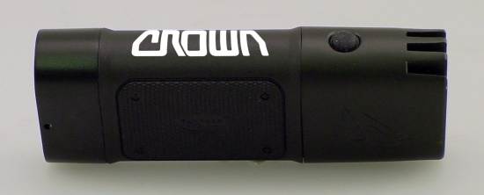
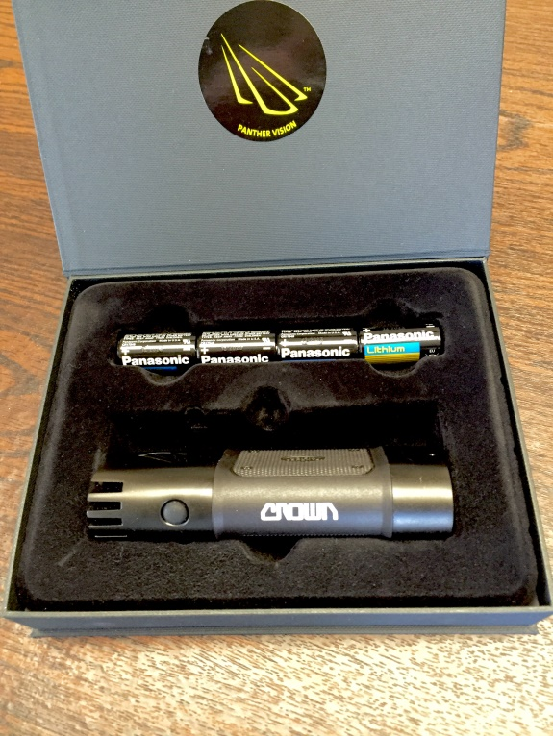
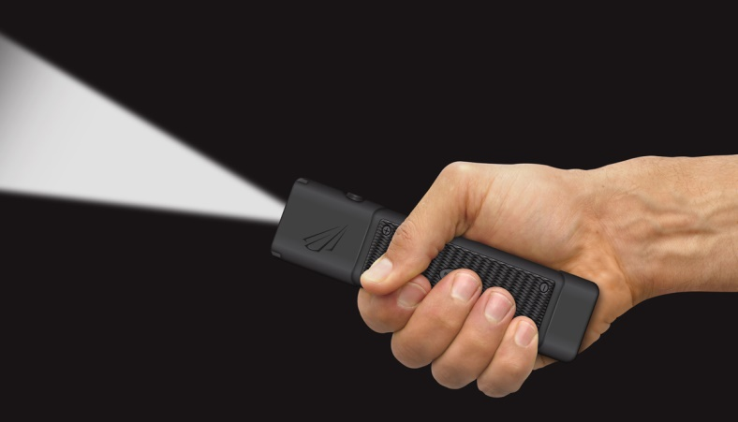
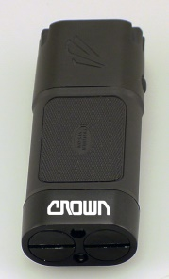

VISIT OUR WEBSITE WWW.PANTHERVISIONPROMO.COM
TO SEE THE FULL LINE OF LIGHTED PRODUCTS
OR CALL 847.783.5900 x 116 FOR MORE INFORMATION

VISIT OUR WEBSITE WWW.PANTHERVISIONPROMO.COM
TO SEE THE FULL LINE OF LIGHTED PRODUCTS
OR CALL 847.783.5900 x 116 FOR MORE INFORMATION

VISIT OUR WEBSITE WWW.PANTHERVISIONPROMO.COM
TO SEE THE FULL LINE OF LIGHTED PRODUCTS
OR CALL 847.783.5900 x 116 FOR MORE INFORMATION

VISIT OUR WEBSITE WWW.PANTHERVISIONPROMO.COM
TO SEE THE FULL LINE OF LIGHTED PRODUCTS
OR CALL 847.783.5900 x 116 FOR MORE INFORMATION

VISIT OUR WEBSITE WWW.PANTHERVISIONPROMO.COM
TO SEE THE FULL LINE OF LIGHTED PRODUCTS
OR CALL 847.783.5900 x 116 FOR MORE INFORMATION

ASI 75825 SAGE 68668 PPAI 318255

VISIT OUR WEBSITE WWW.PANTHERVISIONPROMO.COM
TO SEE THE FULL LINE OF LIGHTED PRODUCTS
OR CALL 847.783.5900 x 116 FOR MORE INFORMATION

VISIT OUR WEBSITE WWW.PANTHERVISIONPROMO.COM
TO SEE THE FULL LINE OF LIGHTED PRODUCTS
OR CALL 847.783.5900 x 116 FOR MORE INFORMATION

Add your information here
We started with the top of the line Cree® LED’s and built a
better flashlight around it.

Add your logo for that personal touch
minimum 48 pieces with logo

Patented Flat Design
Small, compact, won’t roll
Fits in pocket, tool chest or purse

Feels great in your hand

Waterproof to 1 meter (competitors are water resistant)

Shockproof to 3 meters (competitors are only 1M)

Patent Pending heat sink technology

Cree® XLamp LEDs up to 1,000 Lumens

1 color/1 location imprint, as low as $44.22 (s)

600 lumens FL-6243
1000 lumens FL-6250
Comes in beautiful gift box
Imprint on bottom or side
REVOLUTIONARY
FLASHLIGHT DESIGN
Fits easily into pocket, purse, briefcase or toolbox for on the spot lighting

VISIT OUR WEBSITE WWW.PANTHERVISIONPROMO.COM
TO SEE THE FULL LINE OF LIGHTED PRODUCTS
OR CALL 847.783.5900 x 116 FOR MORE INFORMATION
Time to start thinking about holiday gift

